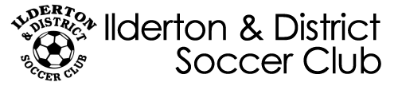

PARENTS CODE OF CONDUCT

- I hereby pledge to provide positive support, care, and encouragement for my child.
- I will encourage good sportsmanship by demonstrating positive support for all players, coaches, and officials at every game, practice, or other youth sports event.
- I will place the emotional and physical well being of my child ahead of a personal desire to win.
- I will insist that my child play in a safe and healthy environment.
- I will support coaches and officials working with my child, in order to encourage a positive and enjoyable experience for all.
- I will demand a sports environment for my child that is free of drugs, tobacco, and alcohol, and will refrain from their use at all youth sports events.
- I will remember that the game is for youth - not for adults.
- I will do my very best to make youth sports fun for my child.
- I will ask my child to treat other players, coaches, fans, and officials, with respect regardless of race, sex, creed, or ability.
- I promise to help my child enjoy the youth sports experience by doing whatever I can, such as being a respectable fan, assisting coaching staff, or providing transportation.
- I understand that I am responsible for the conduct of my child, and will remain on the premises during games and practices.

